I used pivot table to create the "year" field that you asked for. Here is a screenshot of the data from Tableau.

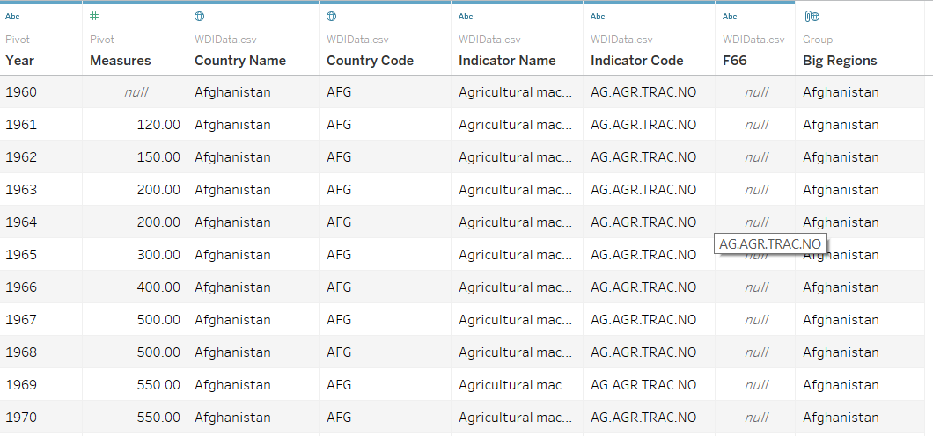

According to this chart, the top 5 countries in terms of CO2 emission per capita are: Aruba, Qatar, Curacao, United Arab Emirates and the Kuwait.

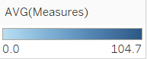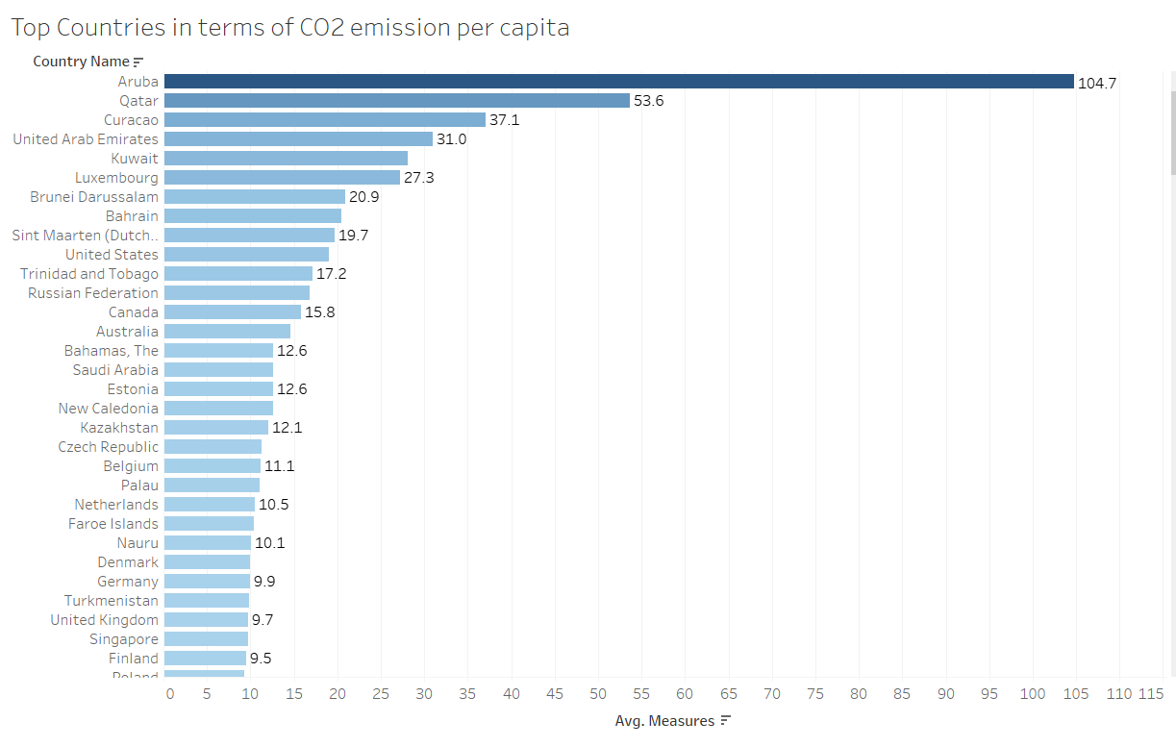

I have built a dashboard and put 3 different visualizations to compare Lebanon to the top 10 countries in terms of CO2.

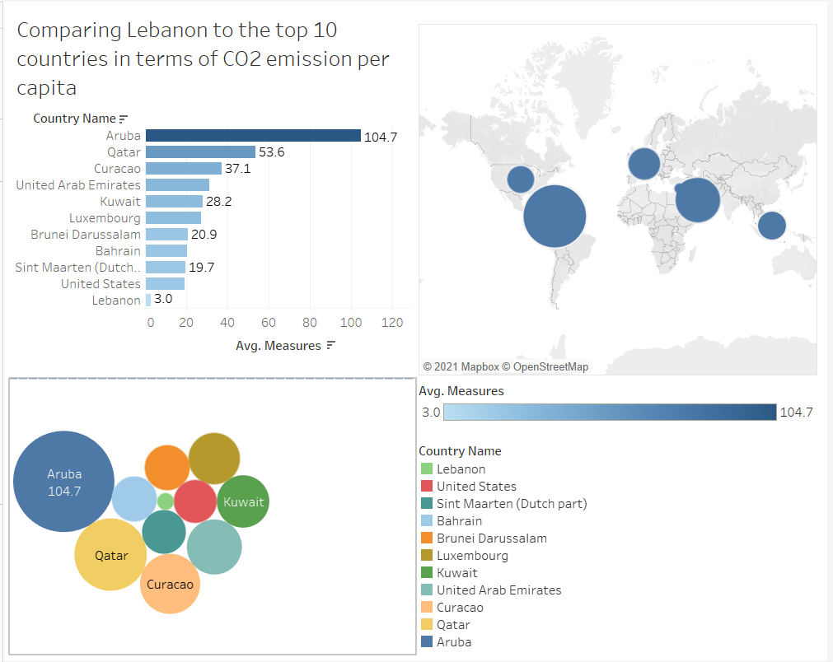

Lebanon falls way off the top 10 countries, as it can be seen from bar chart above. It is 35x lower than the first place, and 5.13x low than the 10th place.

Link to download the data:

https://datacatalog.worldbank.org/dataset/world-development-indicators